|  |  |  |  |  |  |
| --- | --- | --- | --- | --- | --- |
| Date | 24-Nov-22 | | | Tester Name | Mayuri Patel |
| Environment | Penfax - Test | | | Login used |  |
| Operating System | Select OS | Version: | Update: | | |
| Software Used | Select Software | Version: | Update: | | |
| Select Software | Version: | Update: | | |
| Release version | 22.4.1 | | | | |
| Title |  | | | | |
| Test Type | Regression | | | | |
| Test Scenario | Update spousal waiver flag or remove the flag | | | | |
|  |  | | | | |
| Expected Results |  | | | | |
| Pass/Fail | Pass | | | JIRA# | N/A |

Describe your steps with screenshots:

Add a Flag:

Search for any MEPP member that have beneficiary listed and Spousal Waiver is unchecked

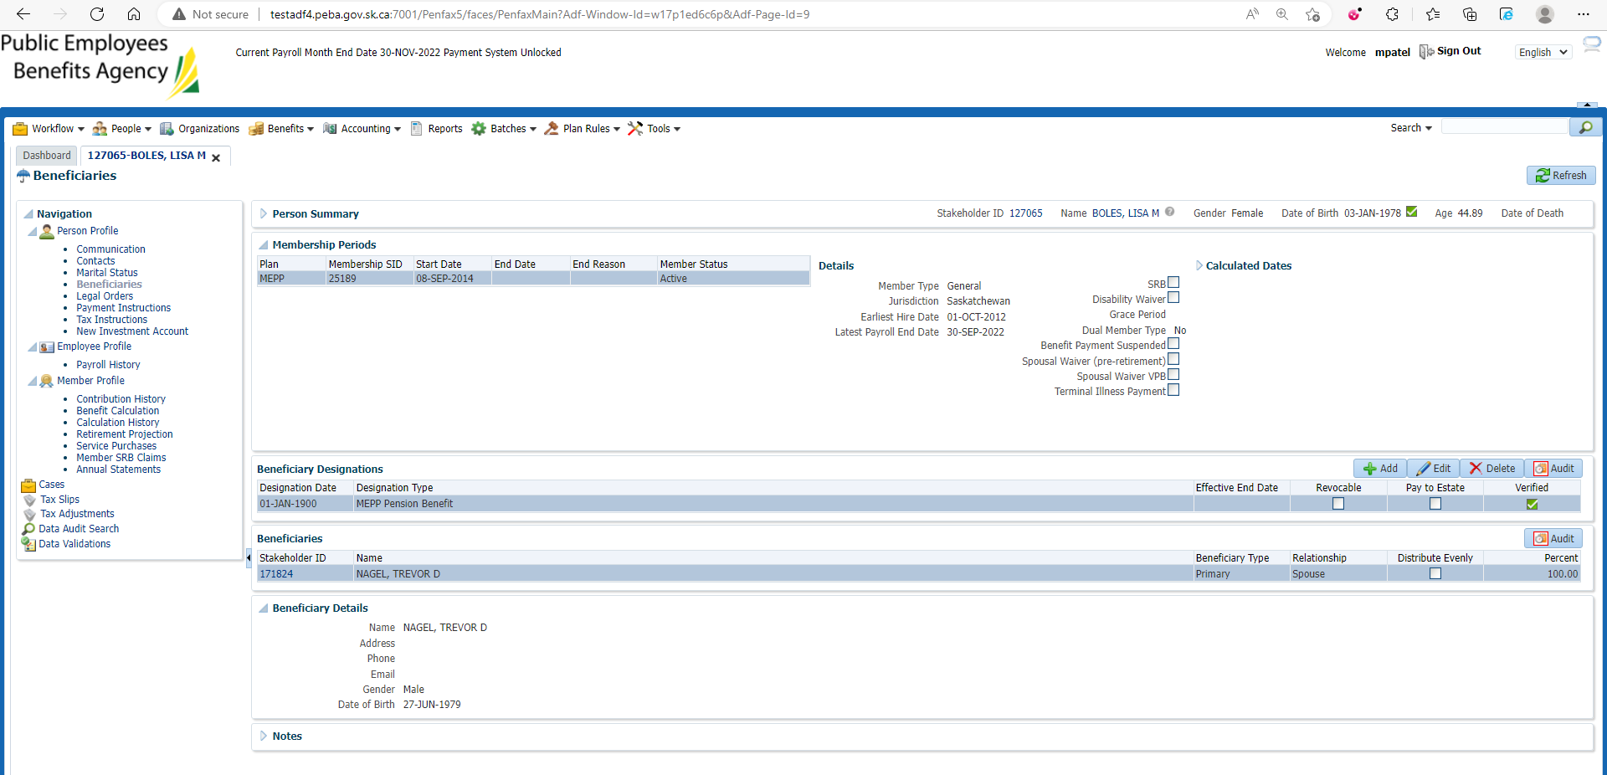

Under Member Profile🡪 Membership Periods

Edit Membership Periods

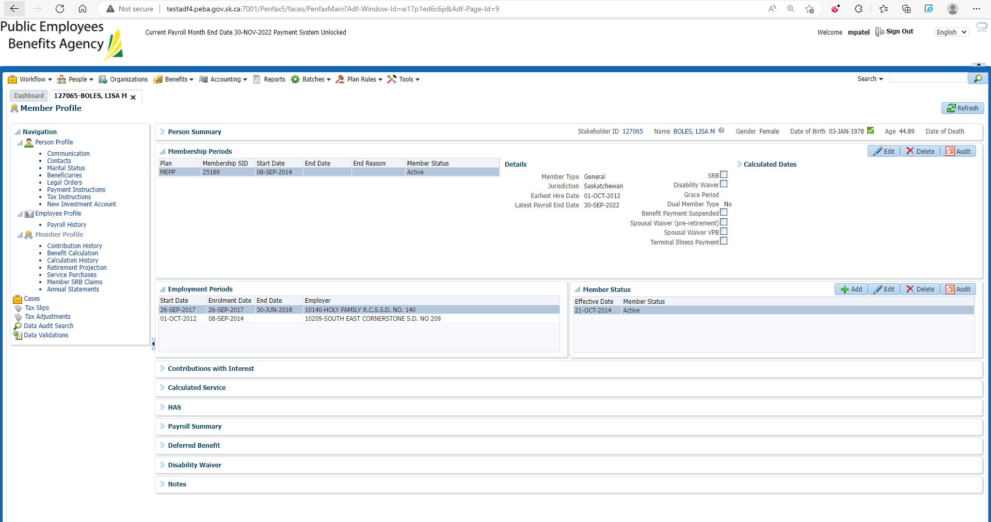

Check Spousal Waiver and save

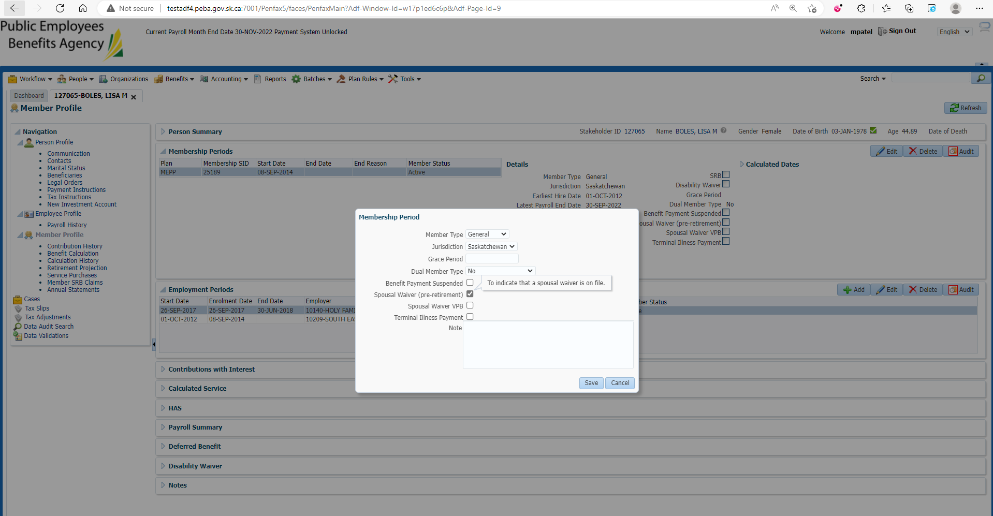

Changes are reflected on Member profile🡪membership Period

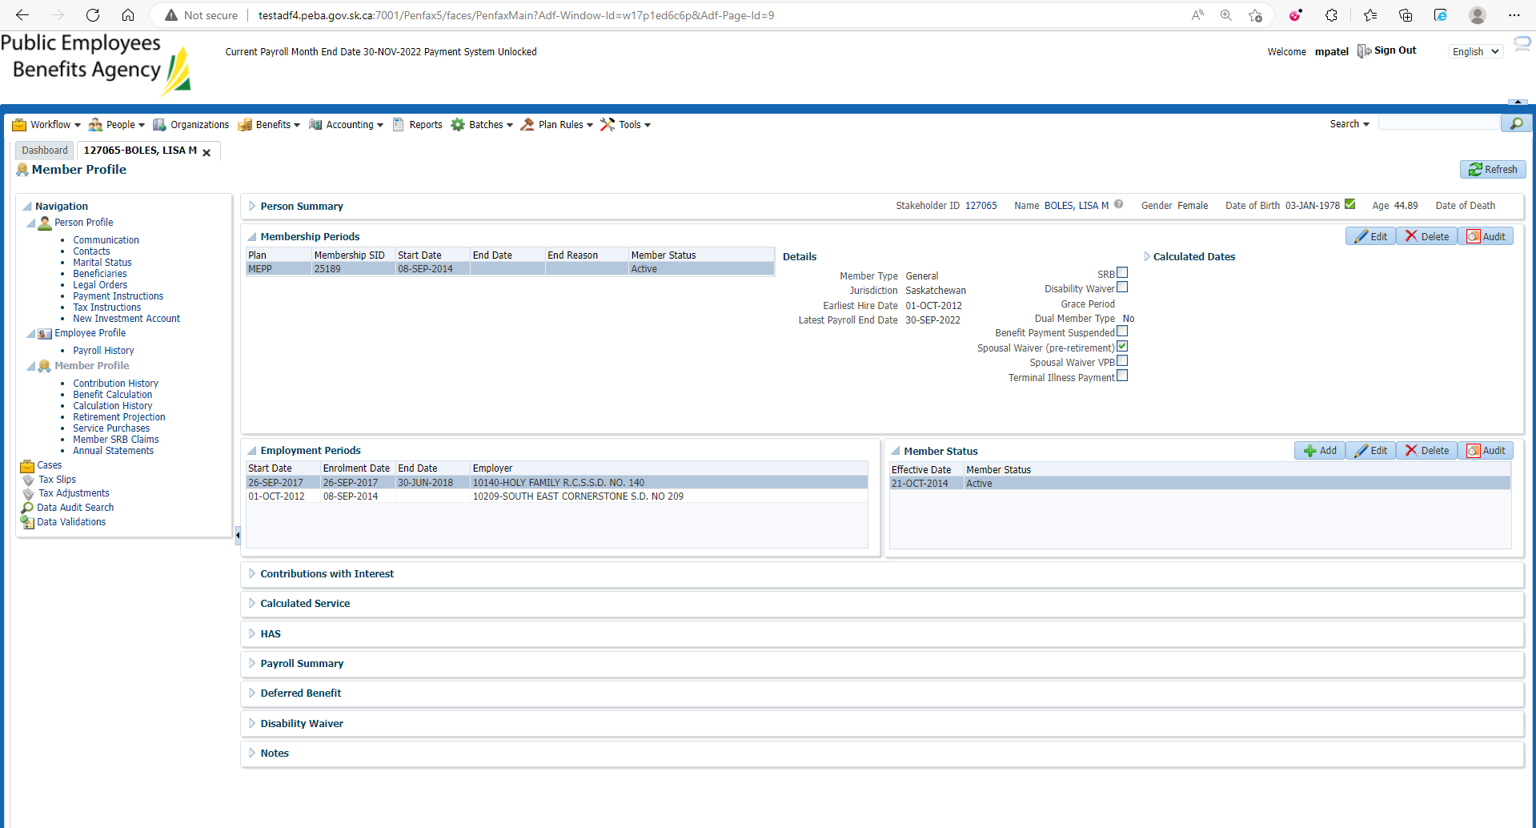

Changes are reflected on Beneficiary🡪membership Period

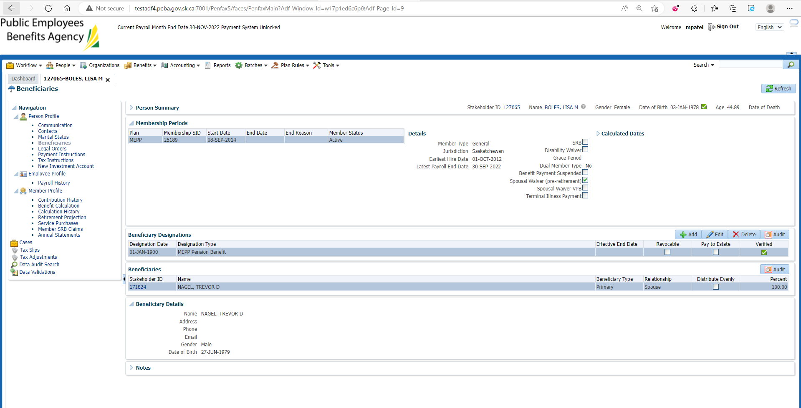

Remove a flag:

Search for any MEPP member that have beneficiary listed and Spousal Waiver is checked

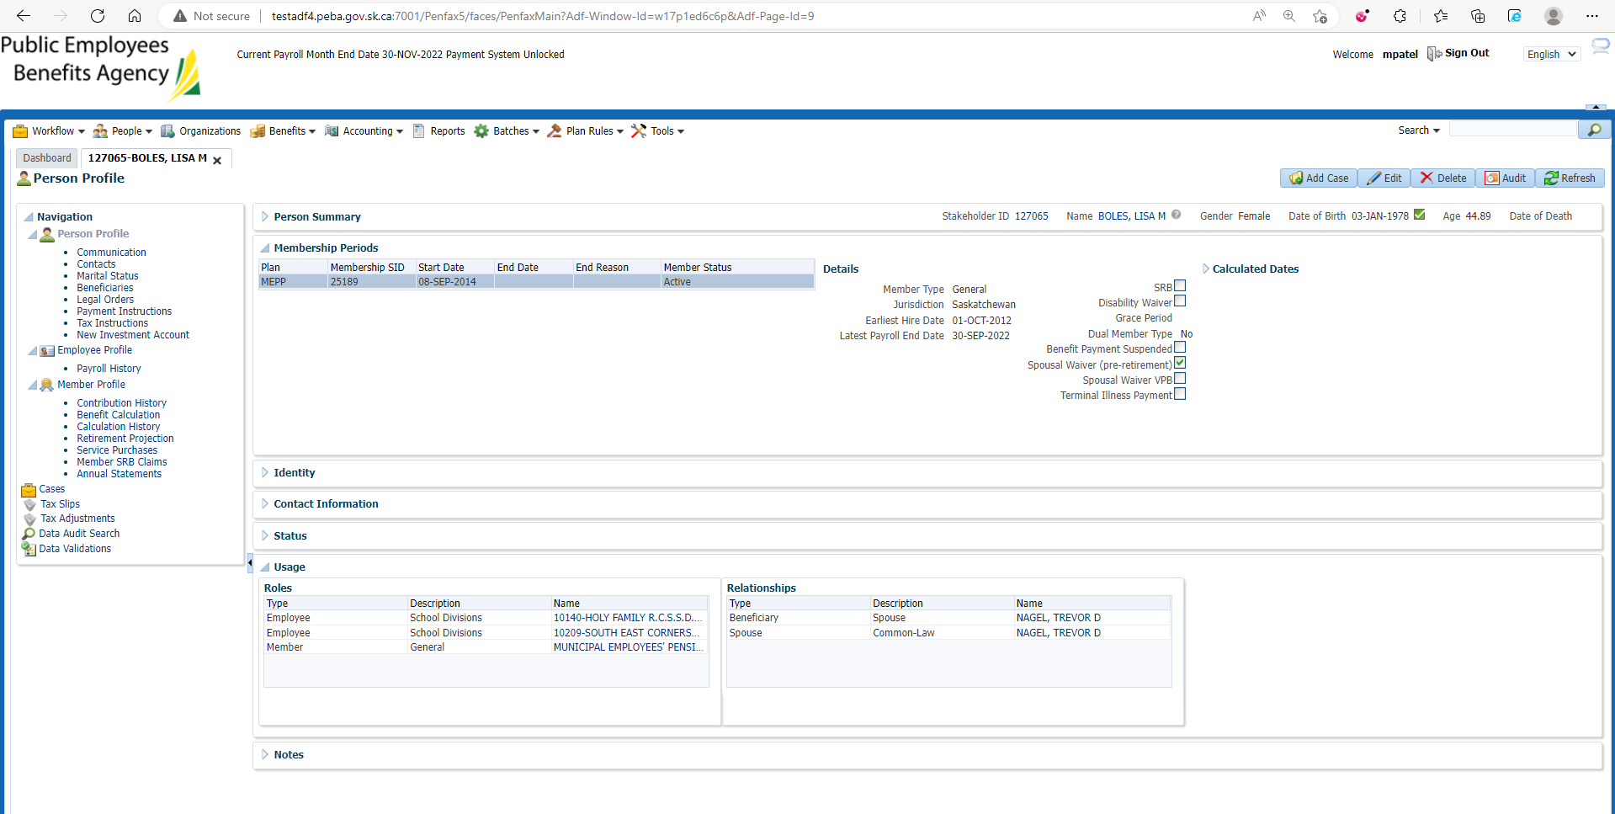

Under Member Profile🡪 Membership Periods

Edit Membership Periods

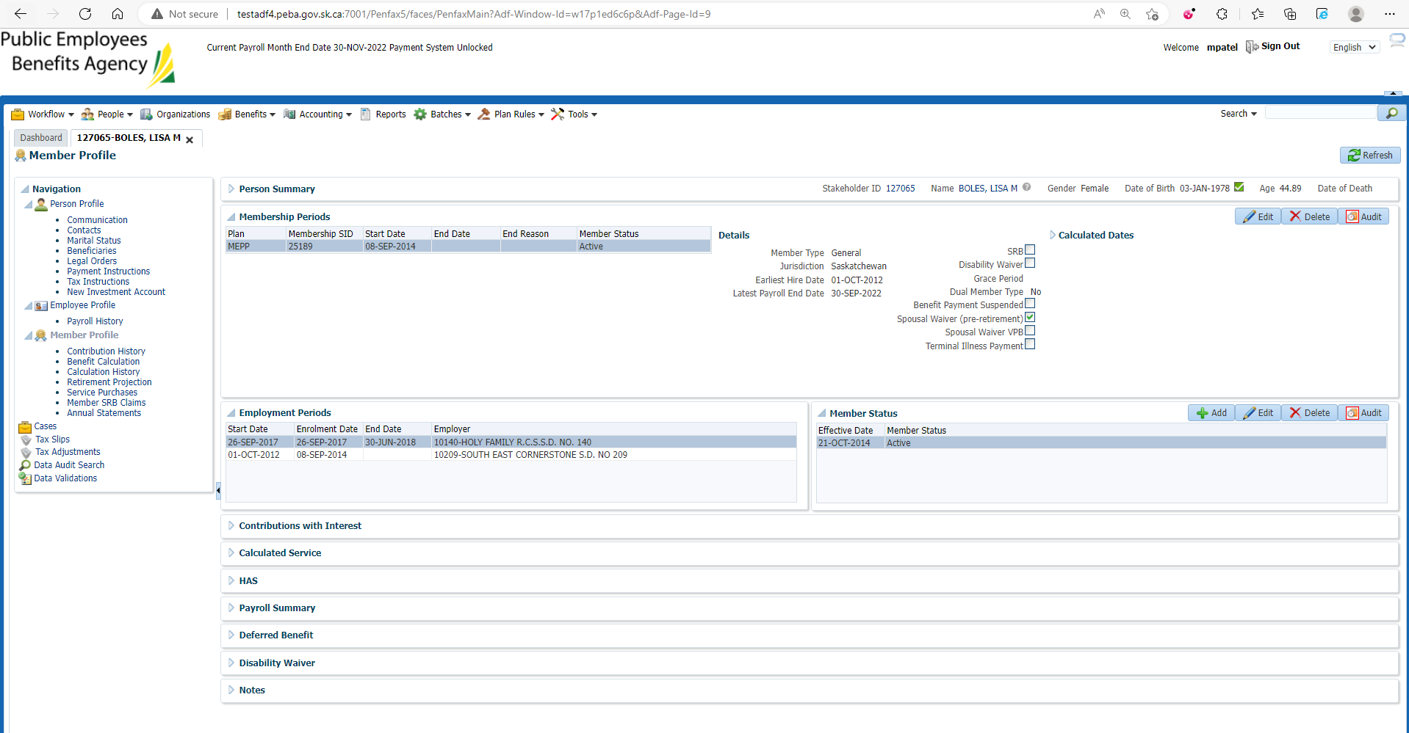

Uncheck Spousal Waiver and save

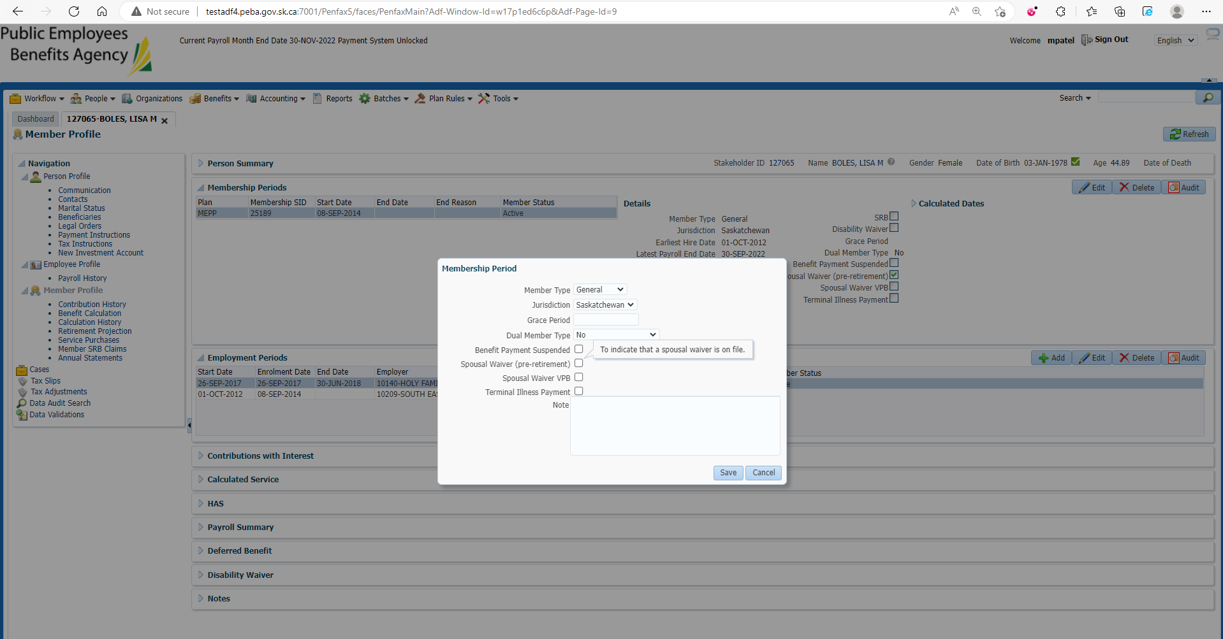

Changes are reflected on Member profile🡪membership Period

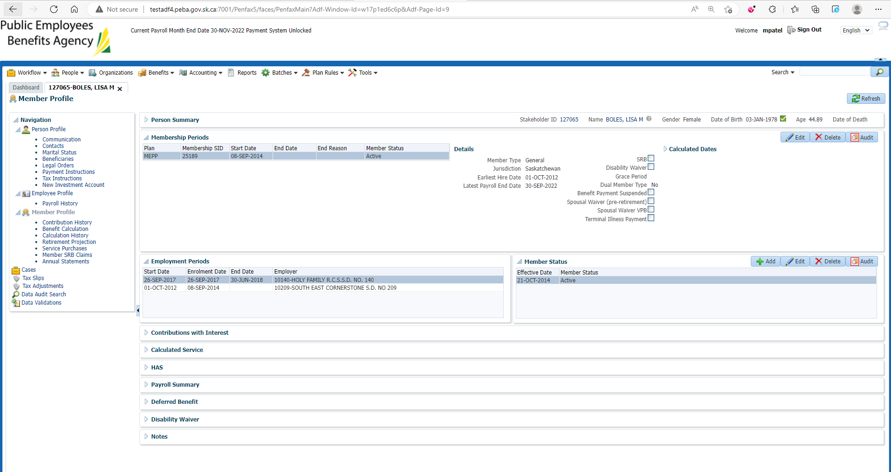

Changes are reflected on Beneficiary🡪membership Period

